230701228

# Exercise 10

Inventory Management System – Documentation

# Overview

The Inventory Management System Visualization project aims to present inventory data effectively using interactive charts built with Chart.js.

This system provides a visual overview of inventory categories and stock levels through Pie Charts and Bar Graphs, improving clarity for inventory analysis.

# Objective

To visualize inventory data using modern JavaScript chart libraries.

To make the distribution of items across various categories easily understandable. To allow quick assessment of stock availability across different product types.

# Technologies Used

HTML5 — Structure of the webpage CSS3 — Basic styling

JavaScript — Logic for data handling and chart generation Chart.js — JavaScript library for building responsive charts

# Project Structure

index.html — Main webpage containing two <canvas> elements for Pie and Bar charts.

script.js — JavaScript file containing data and chart logic.

# Features

Pie Chart representing the distribution of inventory across different categories. Bar Chart displaying the count of items in stock per category.

Responsive Design — Charts adjust to different screen sizes.

Color-coded categories for easy identification.



|  |  |
| --- | --- |
|  |  |
|  |  |
|  |  |
|  |  |
|  |  |
|  |  |

# How It Works

HTML is used to create a basic page structure with two <canvas> elements. Chart.js library is imported via CDN.

Inventory data is prepared in the script.js file.

Two charts are initialized:

Pie Chart (type: 'pie') for inventory distribution.

Bar Chart (type: 'bar') for stock quantity by category.

# Code Snippets

HTML (**index.html**) html

<!DOCTYPE html>

<html lang="en">

<head>

<meta charset="UTF-8">

<title>Inventory Management Visualization</title> <script src="https://cdn.jsdelivr.net/npm/chart.js"></script>

</head>

<body>

<h1>Inventory Management System</h1>

<canvas id="pieChart" width="400" height="400"></canvas>

<canvas id="barChart" width="400" height="400"></canvas>

<script src="script.js"></script>

</body>

</html>

JavaScript (**script.js**) javascript

const inventoryData = {

labels: ['Electronics', 'Clothing', 'Home Appliances', 'Books', 'Toys'], datasets: [{ label: 'Items in Stock', data: [200, 150, 100, 80, 50], backgroundColor: ['#FF6384', '#36A2EB', '#FFCE56', '#4BC0C0', '#9966FF'],

}]

};

// Pie Chart new Chart(document.getElementById('pieChart'), { type: 'pie', data: inventoryData, options: { responsive: true, title: { display: true, text: 'Inventory Distribution'

}

}

});

// Bar Chart new Chart(document.getElementById('barChart'), { type: 'bar', data: inventoryData, options: { responsive: true, title: { display: true, text: 'Items in Stock by Category'

},

scales: {

yAxes: [{ ticks: {

}

}]

beginAtZero: true

}

}

});

# OUTPUT

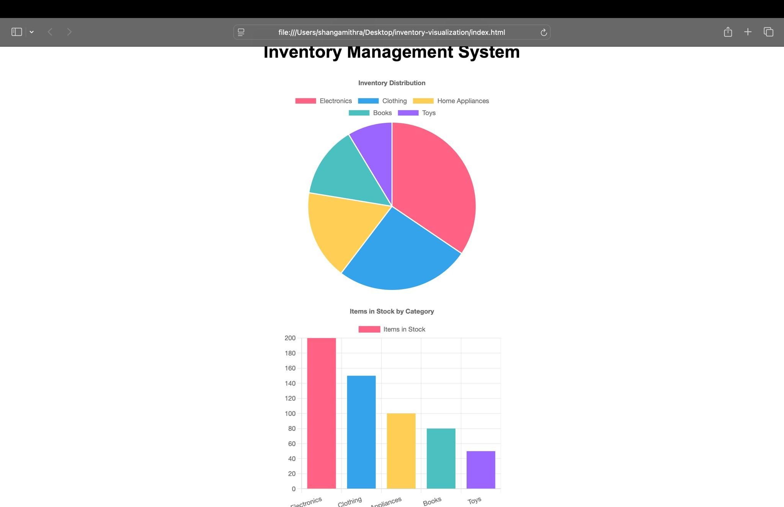

**Conclusion**

The project successfully demonstrates how to visually manage and analyze inventory data using simple web technologies. It offers a quick and intuitive overview that could be extended for real-world inventory management systems.